
Introduction to Monkey Pod Wood

All Dilemma Games wood material comes from sustainable industrial forests.

General Information
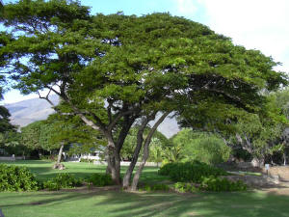
Monkey Pod wood is also known as raintree, saman(its name throughout Latin America) and mimosa(in Phlipine). Monkey-pod is a fast-growing tree that has been introduced to many tropical countries throughout the world from its native habitats in Central America and northern South America.
In Thailand it is farmed for the wood carving industry and is known as Chum Cha wood. Its wood is used for carving, furniture, boat and house construction. It has high durability in water, so furniture made from this wood can be used outdoors.

Wood Properties and suitability to Puzzle Production
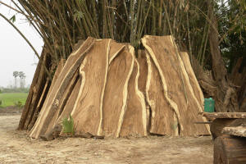
Color: medium tan to dark brown - height: Tree may reach 100 -125 feet tall with a trunk 36-48" diameter. Boles are short, thick and often crooked. The wood: Wavy, interlocked grain with a coarse texture. Takes an excellent finish but requires good woodworking skills for a smooth surface. Typical uses: Furniture, cabinets, turning
Source region: Central, south America, Hawaii, Trinidad and Burma/Thailand
Monkey Pod wood has been reported hard and heavy. Actually, in Thailand the wood is considered easy to work, particularly because low shrinkage during drying allows it to be machined while green. Articles made from green wood can be dried without serious drying degrade Monkey wood has been a premier craft wood used for puzzles and games.
Monkey-pod grows in a broad annual rainfall range of 640 to 3810 mm (25 to 150 in). On wet sites (1270 mm [50 in] or more), its growth is often rapid, making it possible to use the wood as sustaining resources without damage to the environment.
